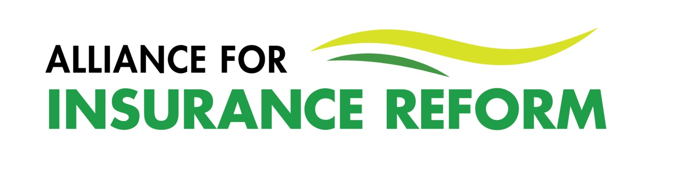
SUMMARY MEMBER UPDATE – JUNE 2023
There are plenty of significant reforms happening at the moment but the real measure of success will be when we see lower premiums, increased market competition and cover for all that need it.
Damages for personal injuries continues to fall with the latest PIAB figures reflecting a 38% reduction in average motor award assessments and a 39% reduction in average liability assessments. This is in the context of a 46% drop in the total number of claims being submitted annually since 2016. Regrettably there a number of challenges pushing back on these positive figures. The Judicial Guidelines which led to the drop in awards is currently subject to a number of legal challenges. The key Delaney case was heard by the Supreme Court in March and a decision is expected in the coming weeks. When multiple injuries are claimed for, we are seeing significant uplifts in terms of awards. Unfortunately, uplifts can vary considerably, with a recent High Court judge holding that uplifts could actually be of higher value than the principal injury claimed for. The Judicial Guidelines will be reviewed early in 2024 and the issue of uplifts needs to be re-examined. New PIAB and NCID figures will be available shortly which will throw further light on how reforms are progressing.
The Courts and Civil Law (Miscellaneous Provisions) Bill 2022 has passed through the Houses of the Oireachtas. This legislation includes a significant reform of the duty of care which, if commenced quickly and implemented fairly, rebalances duties owed to visitors by occupiers and ensures a fairer allocation of personal responsibility across society. We expect the new rules regarding the voluntary assumption of risk to afford protection to a whole swathe of activities where risks are willingly accepted by people well able to comprehend the nature and extent of those risks.
Our key priorities now are to ensure it is commenced promptly by Minister McEntee after President Higgins has signed it into law and that Minister Carroll MacNeill make good on her promise to hold insurers feet to the fire in terms of passing on the savings that will inevitably flow from the changes to the duty of care. The Alliance will provide a more detailed summary of these changes at the time of the Act’s commencement.
The Alliance will now push Government to drive incumbent insurers to deliver the gains expected from the duty of care reforms, as well as raising other key Alliance priorities – increasing competition in the liability market and taking the issue of sectors that cannot get cover seriously.
The Alliance plans to mark the commencement of the changes in the law regarding duty of care with an awareness campaign called “Enough is Enough” to create greater public awareness about the sea-change that this reform intended to bring about. Please watch this space.
A large thank you is due to Peter Boland for all the work he has done in the area of insurance reform. We wish him well in his new role and are very grateful to him for graciously agreeing to remain on the Alliance Board so that his strategic thinking and institutional memory is retained.
How you can help:
- Engage with the Alliance in defining its new objectives to ensure the benefits derived from recent legislative reforms are passed on to policy holders
- Share your personal stories with the Alliance
- If active on social media, like and retweet Alliance content.
Brian Hanley, 29th June 2023

