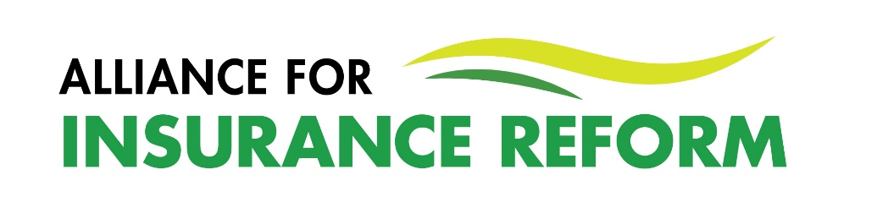
SUMMARY MEMBER UPDATE – March 2024

There have been a number of significant reforms delivered but the real measure of success is when we see lower premiums, increased market competition and cover for all who need it.
The Alliance signed an MOU with the Gardaí providing for Alliance members a direct reporting channel for suspected insurance fraud to the Garda Insurance Fraud Office. This reporting channel should aid the investigation of these claims and is only available to Alliance members and Insurance Ireland presently. The relevant explanatory notes and reporting forms were shared with members recently.
In December last year we had the publication of the Central Bank NCID Annual Motor Report for 2022. It highlighted an increase in the cost of repairs, a 7% reduction in motor premiums and notwithstanding these, a significant 12% profit for insurance companies.
In December we also had the publication of the Injuries Resolution Board Annual Report for 2022. This report evidenced a saving of in excess of €40 million in legal fees for claims processed through the Resolution Board (formerly PIAB). The volume of claims settled through this channel needs to increase as too many claims continue to be settled via litigation where significant legal fees add to the overall value of claims contributing to the cost of insurance premiums. The Injuries Resolution Board also introduced a new mediation service which is being rolled out incrementally across motor, employer and public liability claims this year.
The Alliance launched its “Empowered” insurance information webinar series, providing practical, concise information for organisations on issues such as managing claims, negotiating your premium and navigating the legal process. Attendance at these online sessions has been very high and keep an eye out for the next one which will take place at the end of April.
Our thanks to everyone that participated in the recent Alliance insurance survey. 700 organisations completed the survey and the findings were very clear in terms of the ongoing importance of this issue and the need for improved access to affordable cover, particularly in the area of public liability. The Alliance recently met with Minister Jennifer Carroll MacNeill, who has responsibility for insurance, to share the findings of our research and call for the Government to do more to ensure the savings generated by the reforms are passed on to policy holders and that much more work is done to attract new underwriters to the Irish market.
In April we expect the Supreme Court to deliver its judgement on the constitutionality of the Judicial Guidelines. The Guidelines replaced the Book of Quantum in helping to determine awards in personal injury cases and have contributed to a 41% reduction in the size of awards since their introduction (Injuries Resolution Board, 2022). The importance of this ruling is obvious and the Alliance is ready to welcome their judicial endorsement or call on the Government to introduce caps in personal injury cases, should they become necessary.
The forthcoming Local and European elections are another opportunity for you to raise insurance as an ongoing issue for your organisation. We encourage you to do so in whatever forum you have open to you. With so many of the reforms delivered but not yet delivering “on the ground” in the form of increased access to more affordable cover, it is essential those seeking election hear this message loud and clear from a variety of sources.
Brian Hanley
30th March 2024

